INKATERRA MACHU PICCHU PUEBLO HOTEL
PROMOTES VISIT TO HOME CLINIC SAN JUAN DE DIOS - CUSCO

The children of the Home Clinic San Juan de Dios enjoyed an exciting evening organized by Inkaterra Machu Picchu Pueblo Hotel (ITMPPH) and Inka Terra Asociacion (ITA) with the collaboration of Radio Sonlatina, Red Emprende Ahora (REA) and the Ministry of Culture.

This event took place on January the 6th of 2011 with a program consisting in music, games, stories and theatre. The story telling sessions about “Yogui” the bear were in charge of Arqueologist Bertha Bermúdez (Ministry of Culture) and the theatre presentation of the play “Yogui the bear in Inkaterra Machu Picchu” was played by members of RAE and Radio Sonlatina. Also, Inkaterra made the donation of bedding sets for the clinic.

These activities were coordinated with Mr. Percy Huamaní, manager of the clinic and the visit to the children was guided by Brother Benigno Chahuillco. The staffs of the clinic as well as the parents were delighted with this event and are hoping to have another one very soon.

This kind of activities is very important to create moments of joy that helps to improve the mood of little boys and girls going through therapy.

It must be highlighted the always the unconditional help of Mr. Marc Yeterian, manager of ITMPPH and the collaborative spirit of the INKATERRA staff makes possible these events.

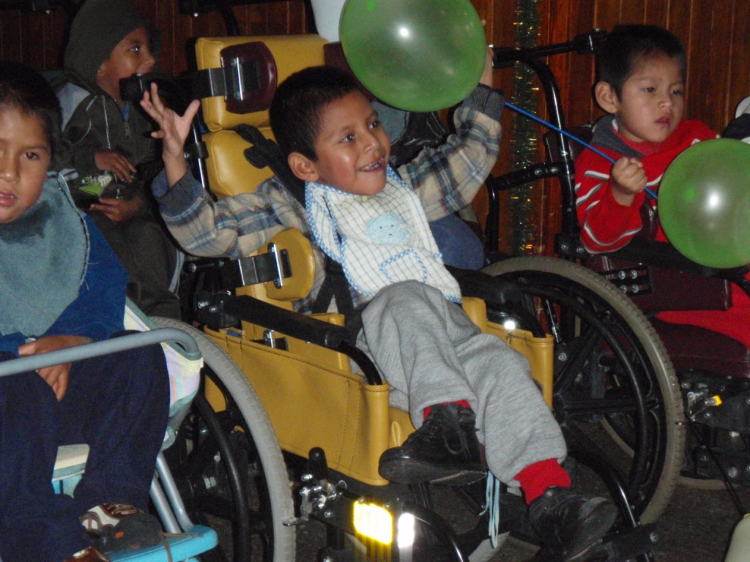
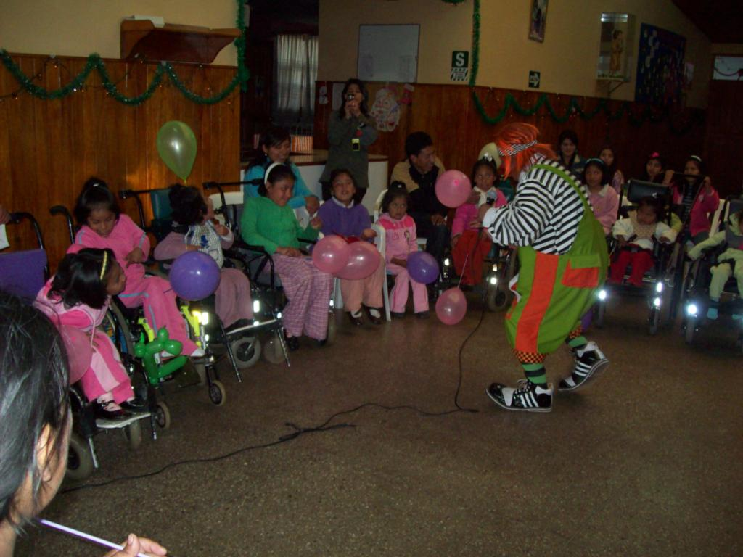
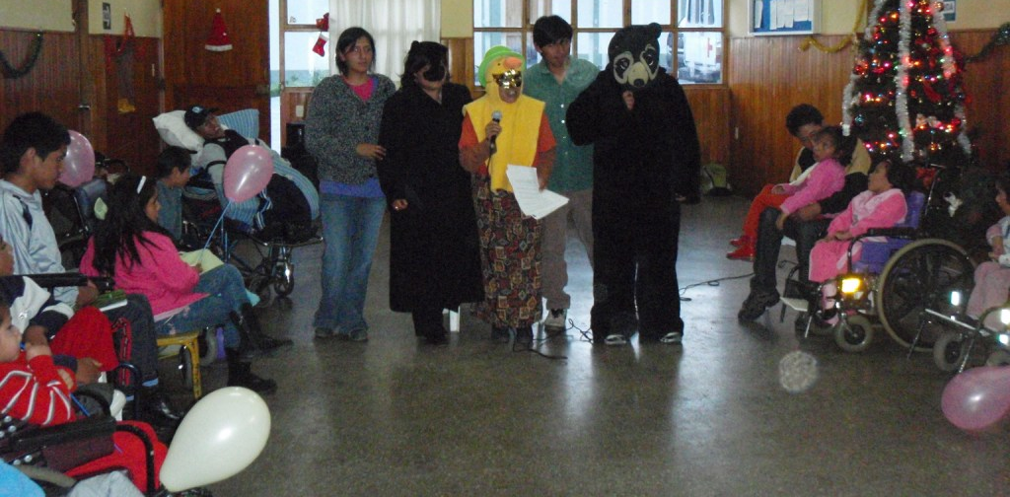
www.inkaterra.com

