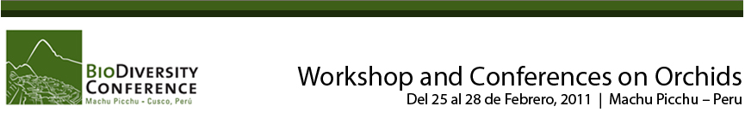
DAY 1 Assistance at the Machu Picchu pueblo (Aguas Calientes) train station and transfer to your hotel / Lunch / Eco-activity / Dinner / Lodging at your selected hotel room/casita.
DAY 2 Breakfast / Field activity / Lunch / Workshop – Part I / Dinner / Lodging at your selected hotel room/casita.
DAY 3 Breakfast / Field activity / Lunch / Workshop – Part II / Dinner / Lodging at your selected hotel room/casita.
DAY 4 Breakfast / Free Morning / Lunch / Check-out and transfer to the train station.

Rates per person in US$

Inkaterra Machu Picchu Pueblo Hotel | Non Residents
In a double Superior casita | 706
Single Supplement | 247
El MaPi Hotel, Hotel Machu Picchu
In a double Superior room | 393
Single Supplement | 90
Inkaterra Machu Picchu Pueblo Hotel | (*) Peruvian & foreign residents in Peru
In a double Superior casita | 828
Single Supplement | 290
El MaPi, Hotel Machu Picchu
In a double Superior room | 461
Single Supplement | 106

BOTH PACKAGES:

- Include:
  - Assistance between the Machu Picchu pueblo (Aguas Calientes) train station and the hotel of your choice, and return
  - Lodging for 3 nights in the hotel of your choice
  - Field-activities, according to the workshop of your choice
  - Dinner, breakfast and lunch at the hotel of your choice
  - Coffee breaks during the workshops

(*) The rates for Peruvian & foreign residents in Peru - up to a maximum of 60 consecutive days within the country - include the VAT (IGV 19%)

- Do not include:
  - Transport to and from Machu Picchu pueblo (Aguas Calientes)
  - Guided visit to the Machu Picchu Citadel
  - Visits, activities and excursions not mentioned in the program
  - Extras and personal expenses

WORKSHOPS:

Applicable rate for your participation in Workshops I & II: $ 150.00 per person

