VIRTUOSO TRAVEL WEEK 2012

**Representatives:** Liza Masias / Michele Barton / Clark Kotula / Judy Hurst

Once more Virtuoso Travel Week, the most important luxury fair in the United States, was a whole success with the participation of more than 1500 Virtuoso Agents from US, Australia, Mexico, Brazil, Canada among others, and 900 suppliers from all over the globe. The event, running August 12-16, was well organized as always, under the format of “One on One” business appointments. The idea was to bring to Virtuoso members the experience of a buying trip in the search of the best options for their clients.

Before Virtuoso Travel Week came VAST (Virtuoso Active and Specialty Travel), on August 11. VAST was a very interesting added value to Virtuoso, where Inkaterra showcased a stand that 300 travel agents visited. Our sales representatives in the US Clark Kotula and Judy Hurst, were there bringing a personalized attention and familiar touch to the clients they know.

Among the attendees at the opening ceremony were the main Virtuoso representatives such as Matthew D. Upchurch, CEO Chairman; and Kristi Jones, Virtuoso President. Francis Ford Coppola, famous film director, was a special guest at the ceremony where he took the chance to share his recent experience in the hospitality industry.

First day morning of Virtuoso Travel Week, PromPeru organized a business breakfast with more than 130 travel agents and various Peruvian suppliers such as Abercrombie & Kent, Orient Express, Hoteles Libertador, Andean Experiences, and Inkaterra Experiences. At the breakfast Inkaterra had the opportunity to invite the attendees to live the Inkaterra Experience and delivered an award certification for a stay at Inkaterra Machu Pueblo Hotel for 3 days / 2 nights in a double suite.

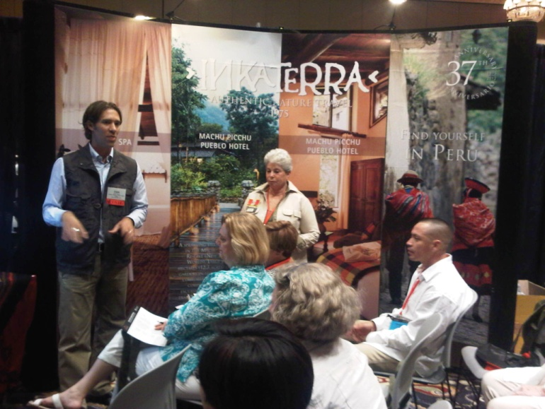Inkaterra brand stood out for its recognitions, positive comments about the experience offered, leaving among the attendees a clear interest in the brand. Most of the contacts showed special interest in the Relais & Château itinerary in Peru and congratulated the inclusion of Inkaterra Machu Picchu Pueblo Hotel as the second Inkaterra’s R&C property.

